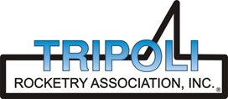
Tripoli Motor Testing Division
223 NC Highway 54 West
Chapel Hill, NC 27514
(919) 357 5681 (c)
October 18, 2021

Gary Rosenfield
RCS Rocket Motor Components, Inc.
2113 West 850 North Street
Cedar City, UT 84721

Dear Mr. Rosenfield,

The Aerotech N1975W-PS motor was tested on October 16, 2021 and is in compliance with NFPA 1125. The motor is certified for hobby rocketry use by the members of the Tripoli Rocketry Association and all approving organizations with reciprocal certifying agreements.

Motor Manufacturer Aerotech Division, RCS Rocket Motor Components
Manufacturer’s Designation N1975W-PS [DMS, single use]
Propellant White Lightning
TMT Nomenclature 13,893 N1971

Diameter 3.874” 98.39 mm
Overall Length 43.706” 1110.13 mm
Length Inside 40.956” 1040.28 mm
Length Outside 2.750” 69.85 mm

Loaded Mass 26.915 lb 12,208.43 g
Propellant Mass 16.923 lb* 7676 g*
Burnout Mass 9.040 lb 4100.47 g
* data provided by manufacturer

Burn time 7.048 ± 0.127 sec

Total Impulse 3123.29 ± 45.46 lbf.s 13,893.1 ± 202.23 N.s
Max Impulse 652.67 ± 70.75 lbf 2903.25 ± 314.73 N
Average Impulse 443.4 ± 1.55 lbf 1970.7 ± 6.93 N
Number of Motors Tested 2

Nominal Measured
Delay Time Data n.a. n.a.

Casing Temp. [NFPA 1125 7.4.1] Passed

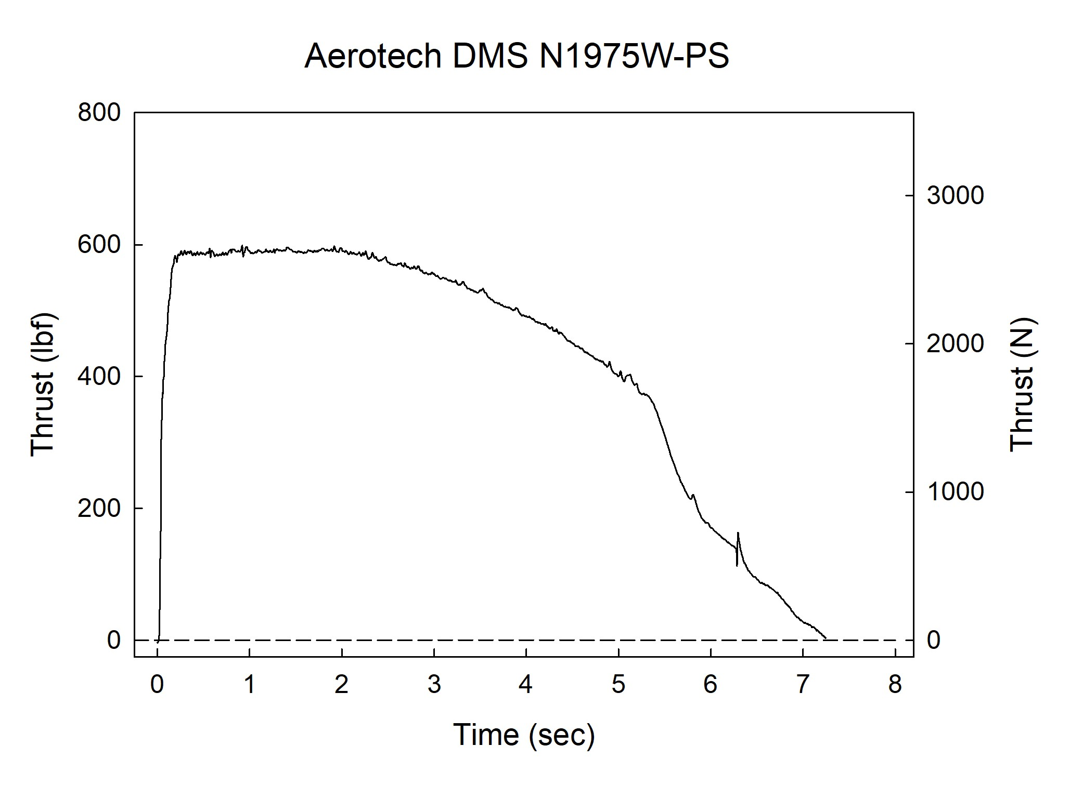

Sincerely,

Alan C. Whitmore
Chair, Tripoli Motor Testing

